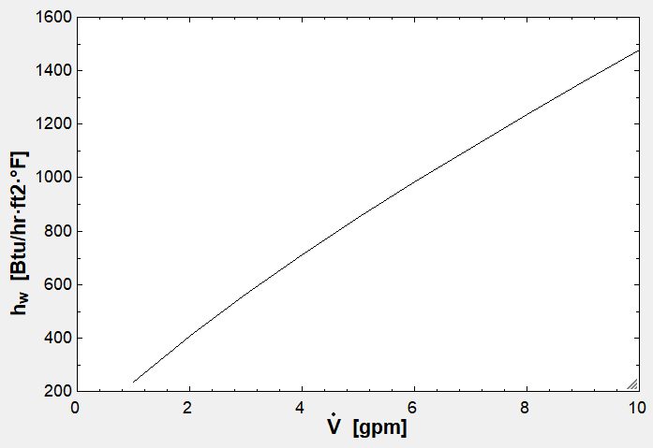

**Figure 1.** Heat transfer coefficient as a function of flow rate.

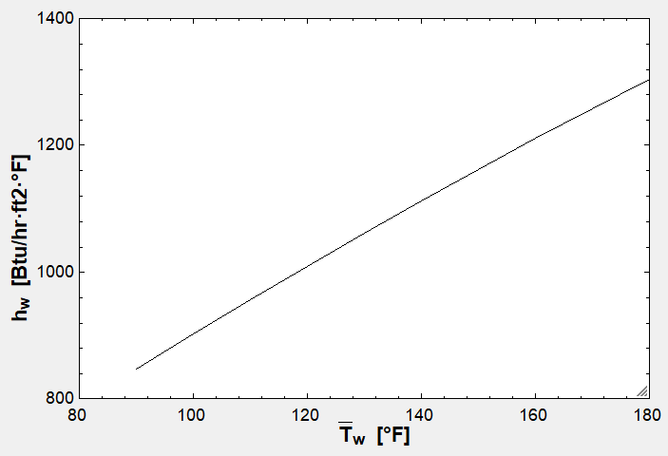

**Figure 2.** Heat transfer coefficient as a function of mean temperature.

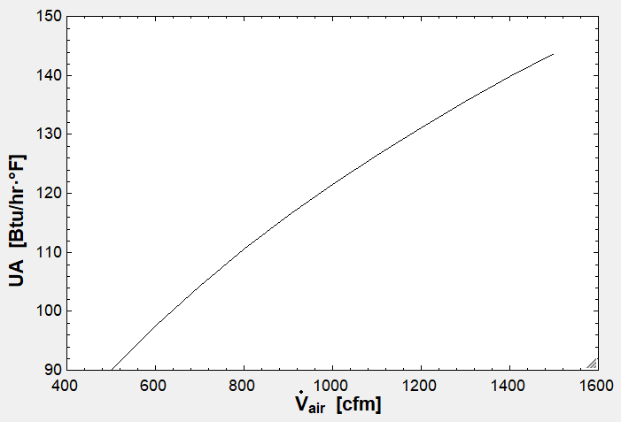

**Figure 3.** UA value as a function of flow rate.

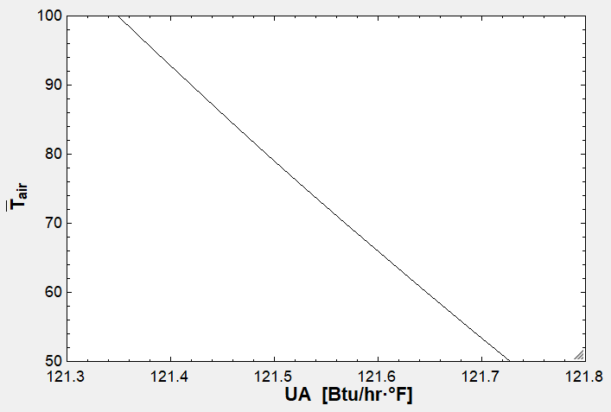

**Figure 4.** UA value as a function of average air temperature.